Exemple de comenzi git, utilizare SourseTree (material ajutător)

Contents

1. Create a local repository in lab4 3

2. Create SSH Key if it’s necessary 3

3. Create remote GitHub public repo 6

4. Solving the conflict using the text editor 14

5. git merge --squash 22

6. git revert 27

7. git push origin/master 30

8. git rebase 31

9. git –amend 37

10. git cherry-pick 38

11. git reset 39

# Create a local repository in lab4

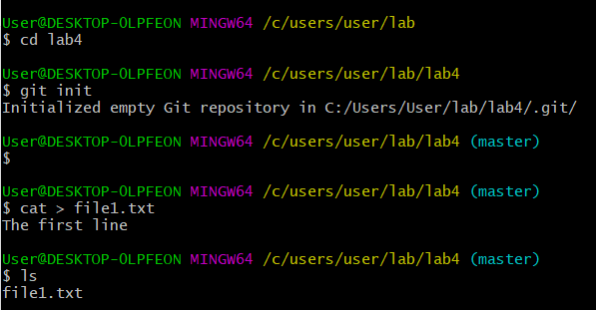

# Create SSH Key, if it’s necessary

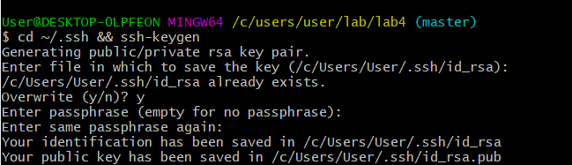

If you didn’t introduce another name for the key, your public key has been saved in id_rsa.pub file

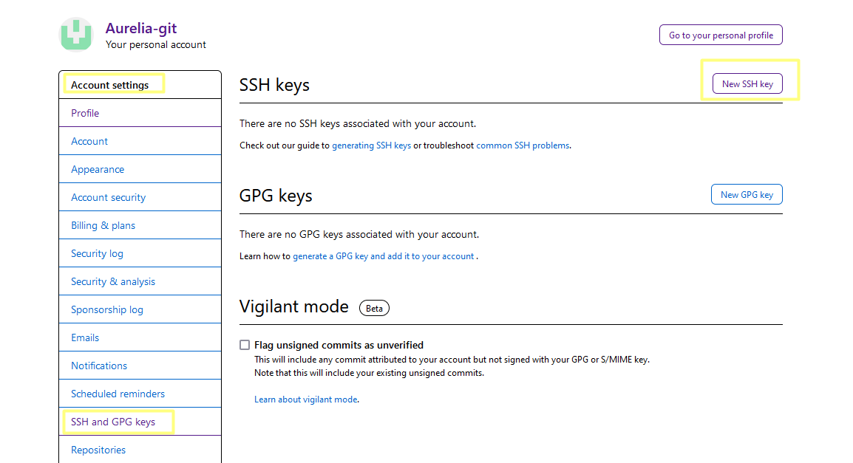

Copy the content of id_rsa.pub to github and press “Add SSH key”:

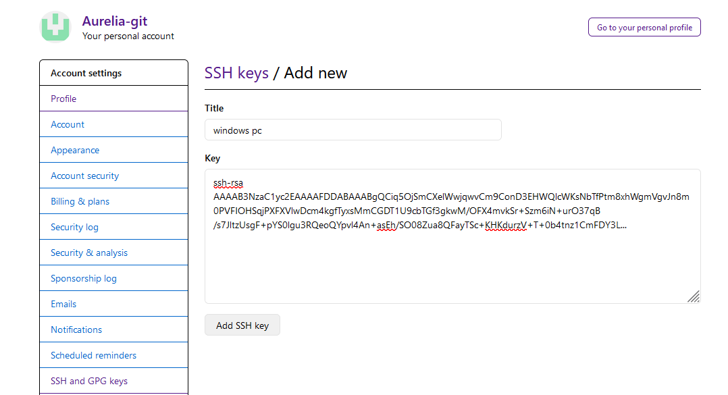

Create the first commit – C1 in the local repo:

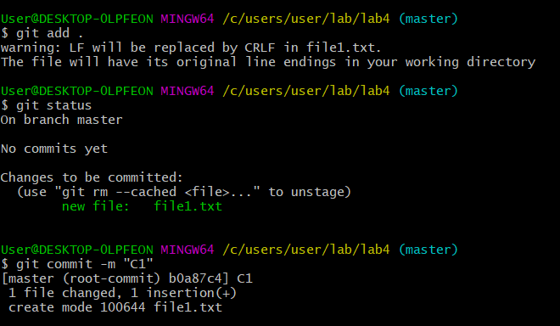

Add a local repo (lab4) to SourceTree:

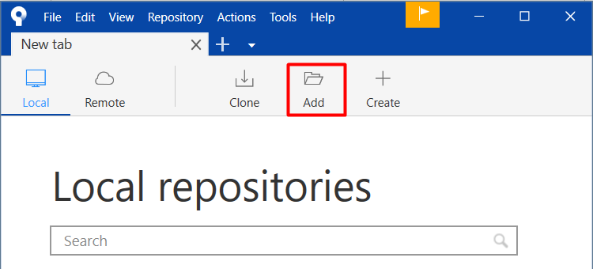

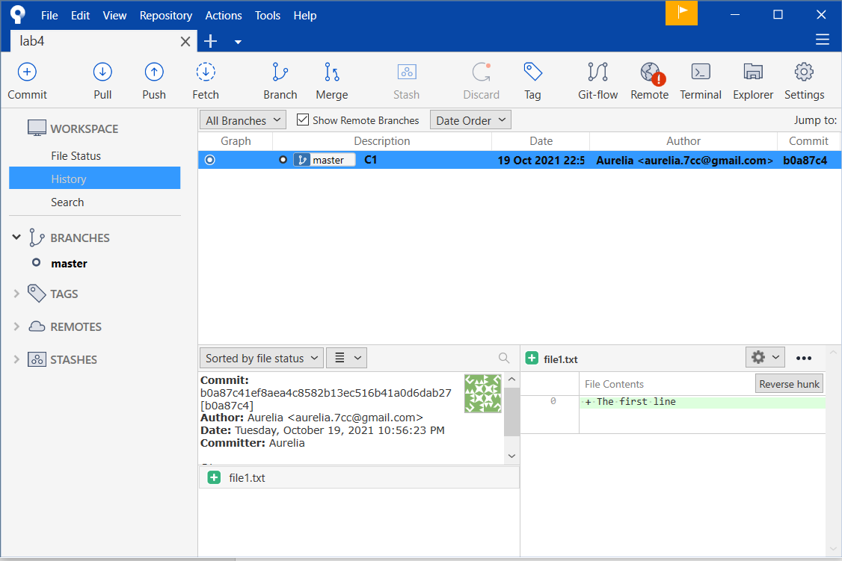

# Create remote GitHub public repo

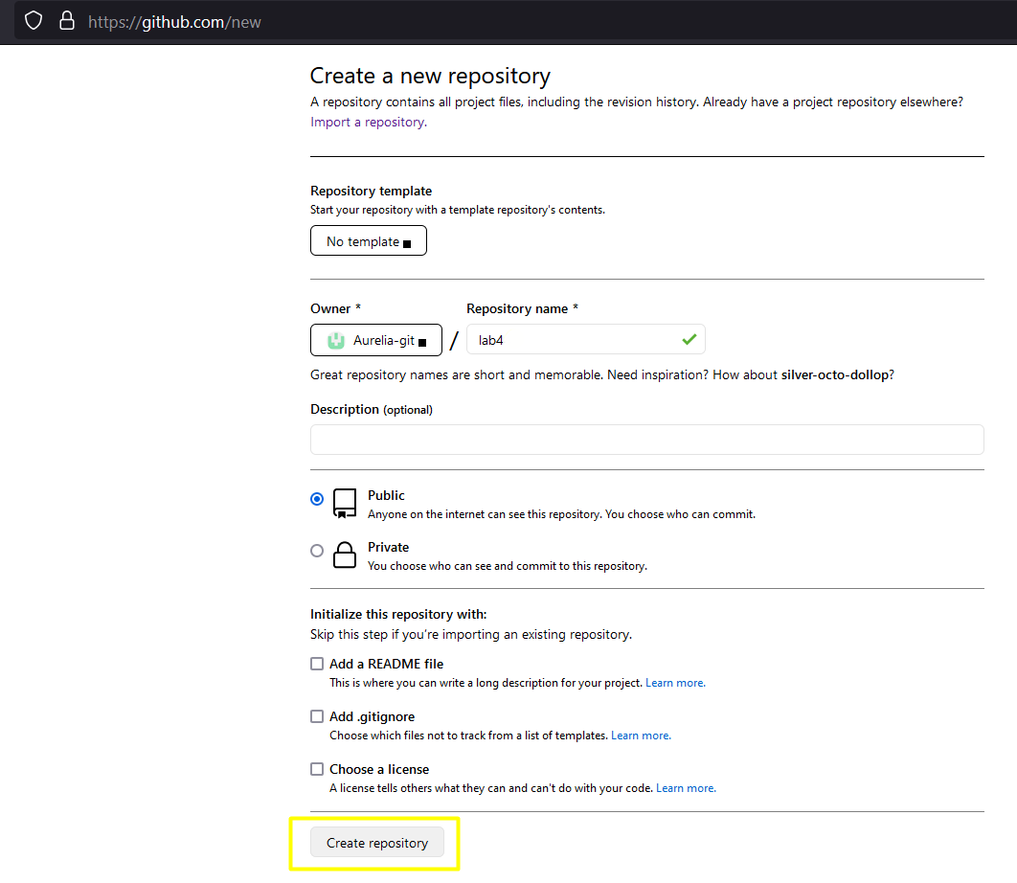

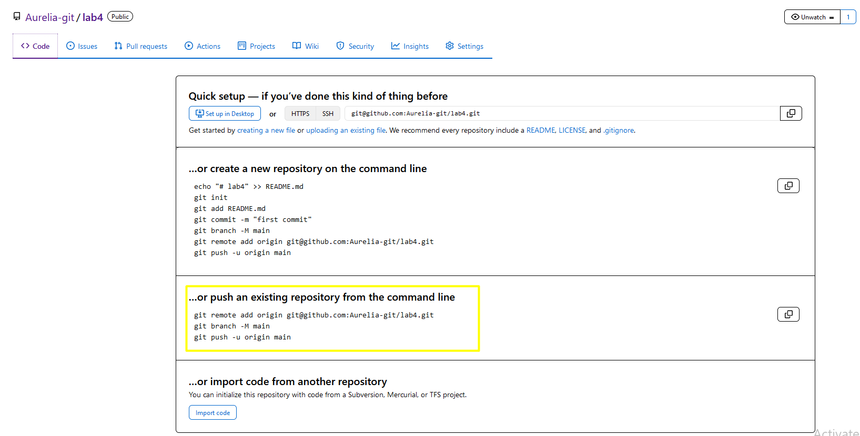

Add a new remote repo:

Branch 'master' set up to track remote branch 'master' from 'origin'.

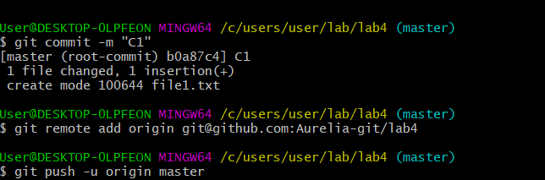

To add a new remote, use the **git remote add** command on the terminal, in the directory your repository is stored at.

**git push -u origin master** is used for pushing local content to GitHub. In the code, the origin is your default remote repository name and '-u' flag is upstream, which is equivalent to '-set-upstream. ' and the master is the branch name.

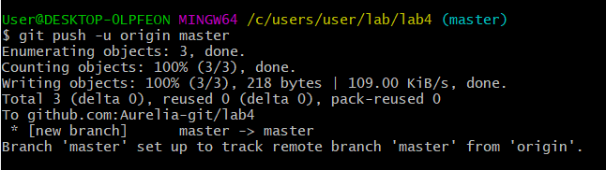

**Now we create a new branch newBranch and HEAD will point to it:**

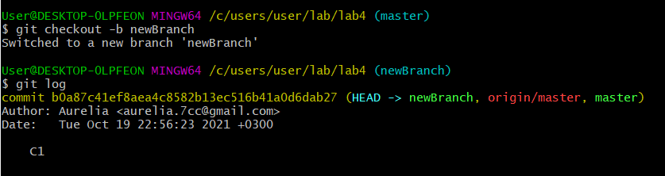

All our branches (master, origin/master and newBranch) point to the same commit C1:

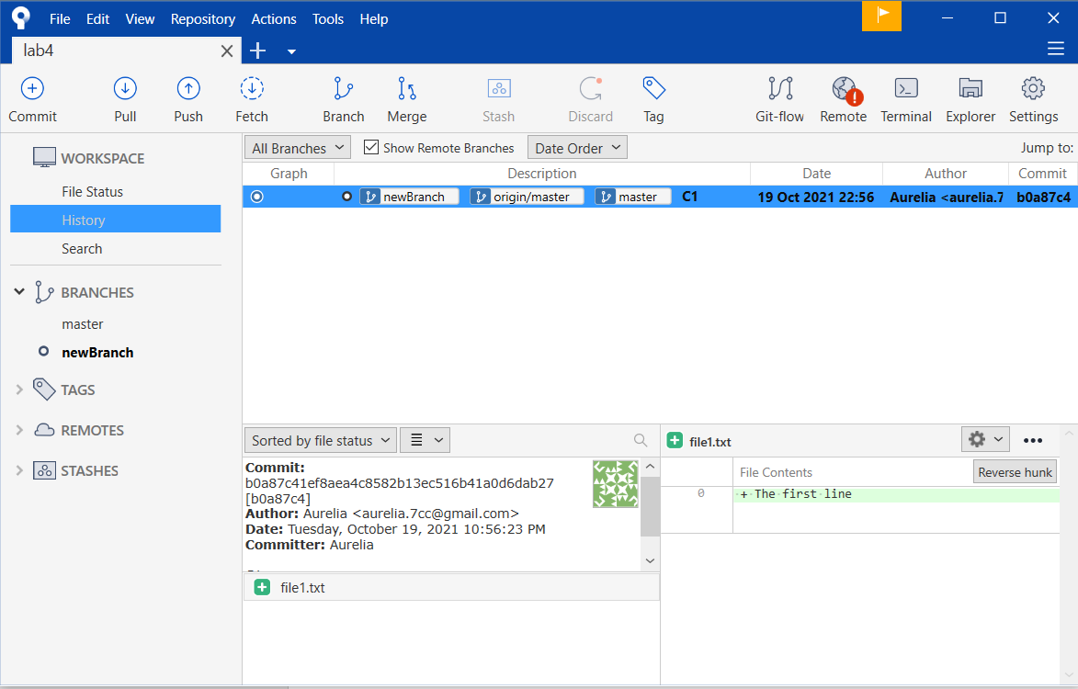

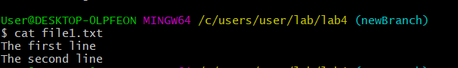

Create the commit C2 on newBranch:

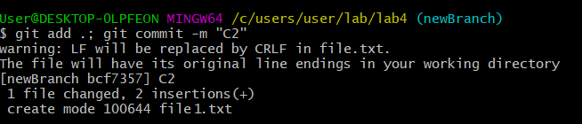

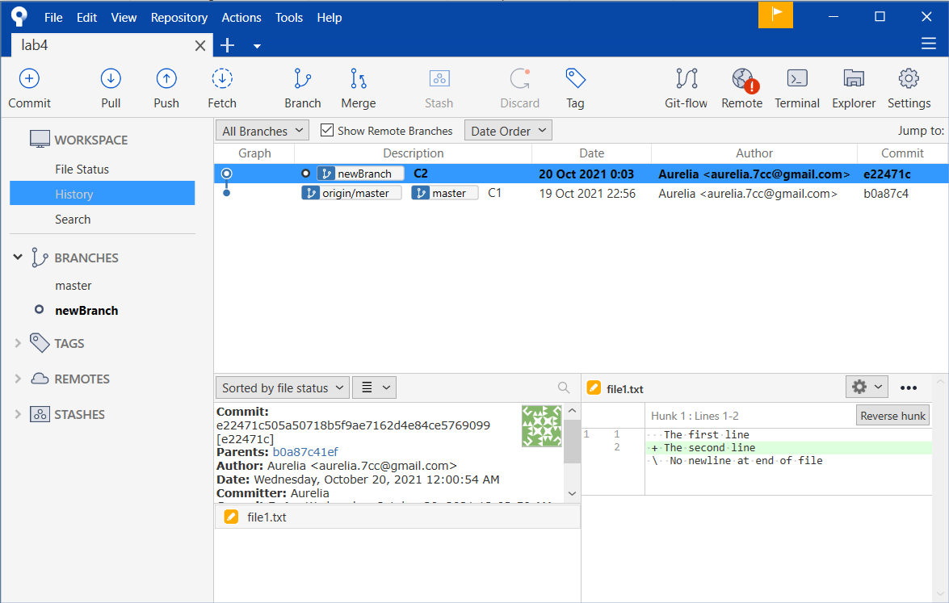

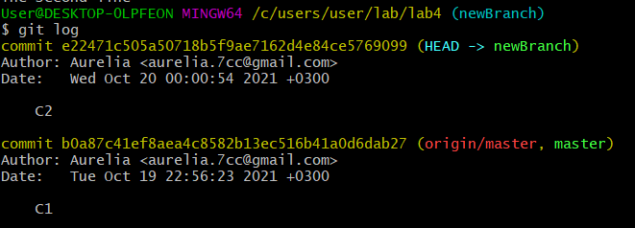

Checkout master branch and make C3 commit

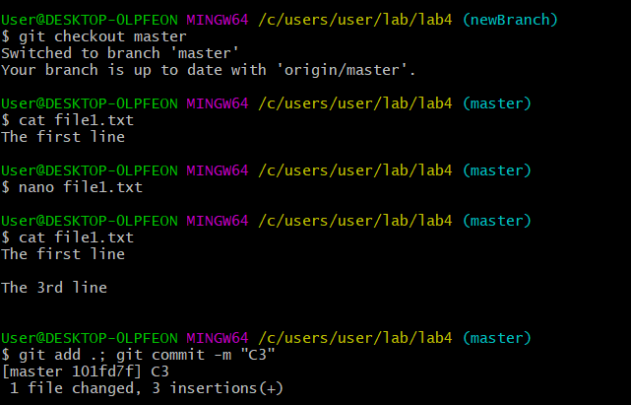

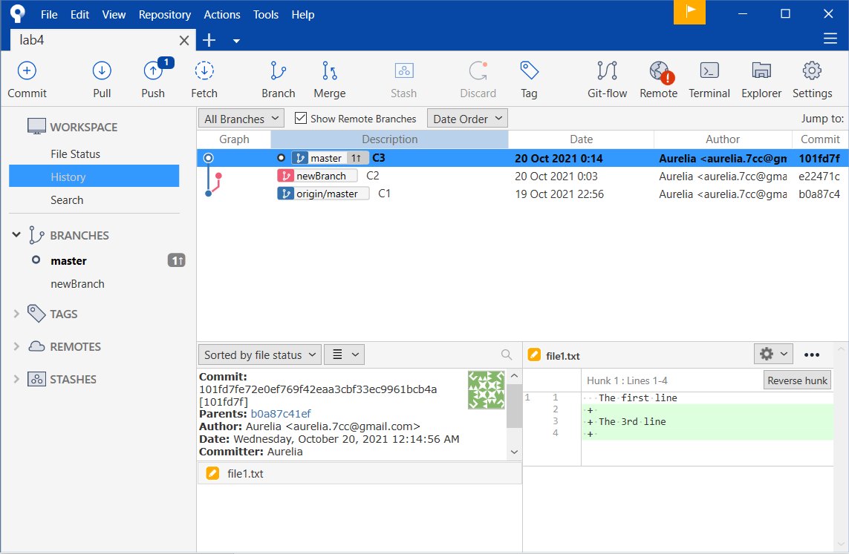

**git merge:**

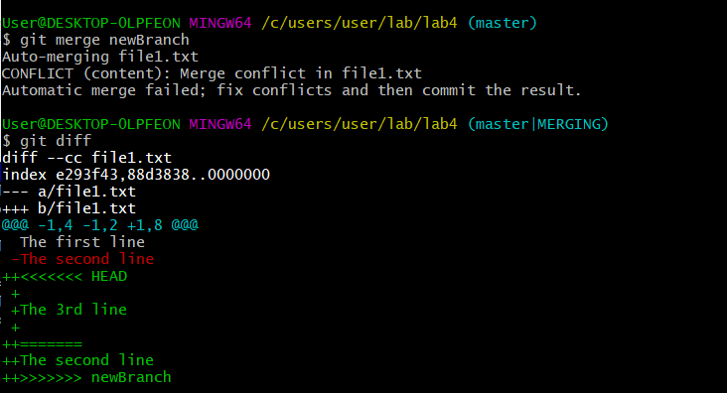

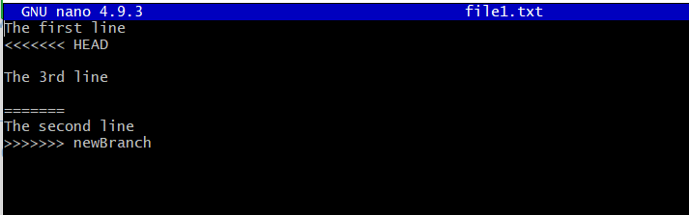

# Solving the conflict using the text editor

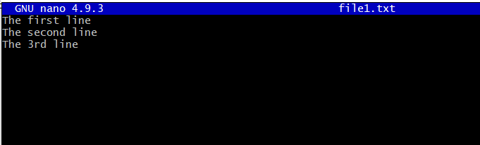

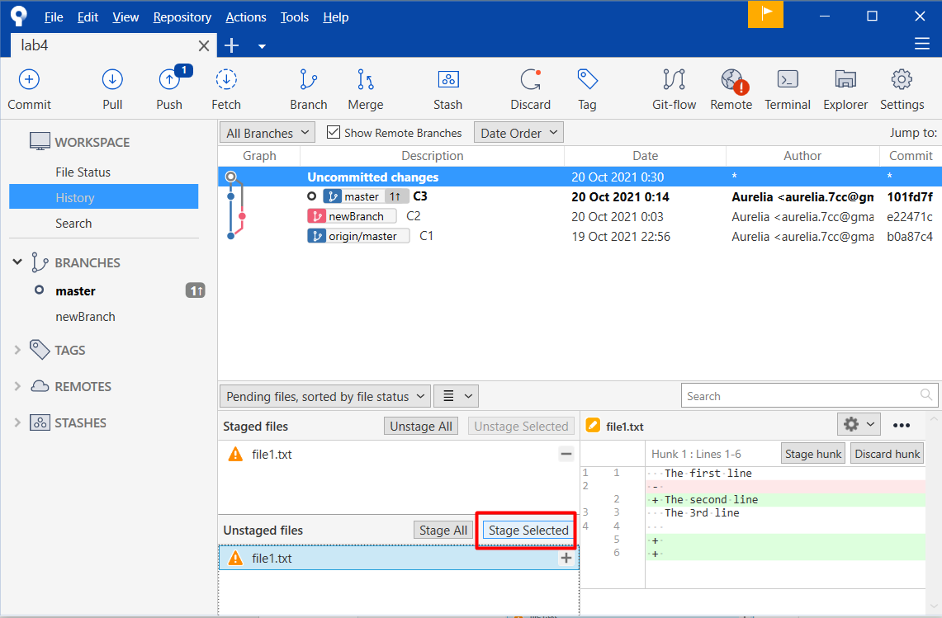

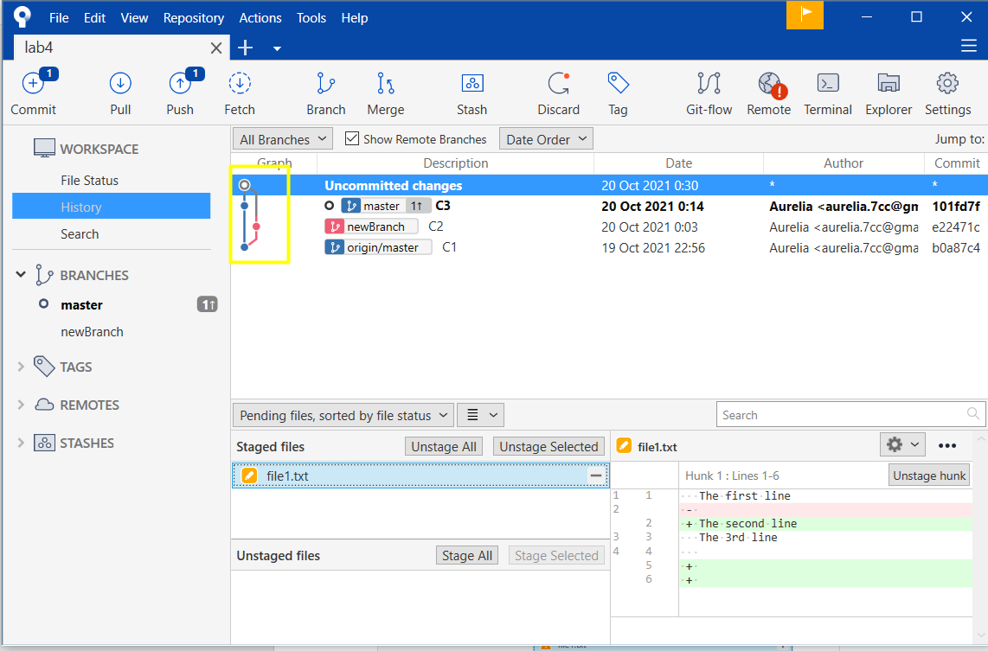

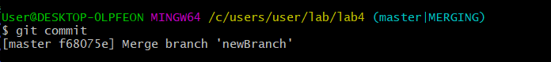

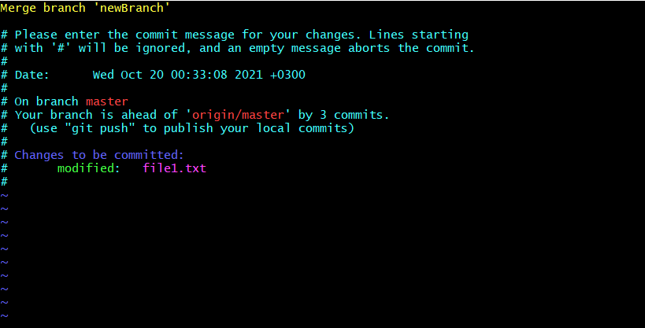

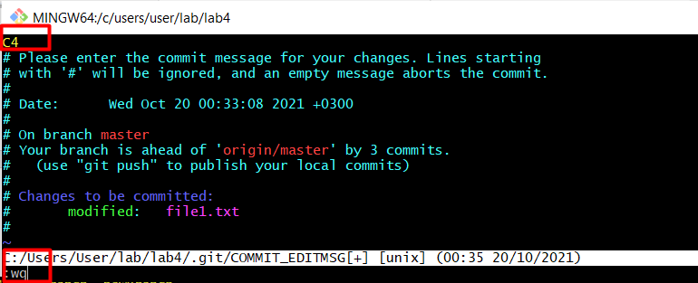

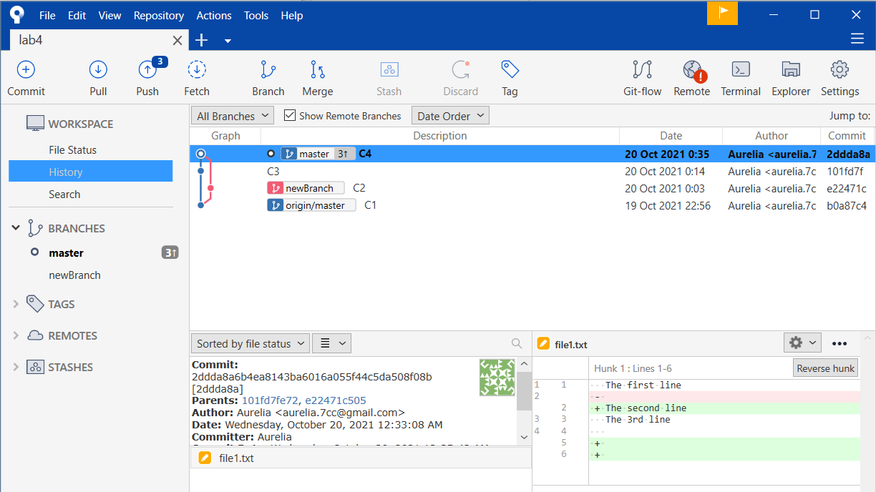

Deleting newBranch:

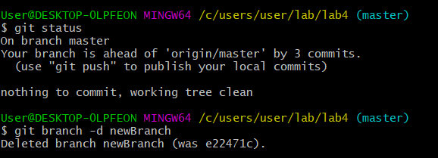

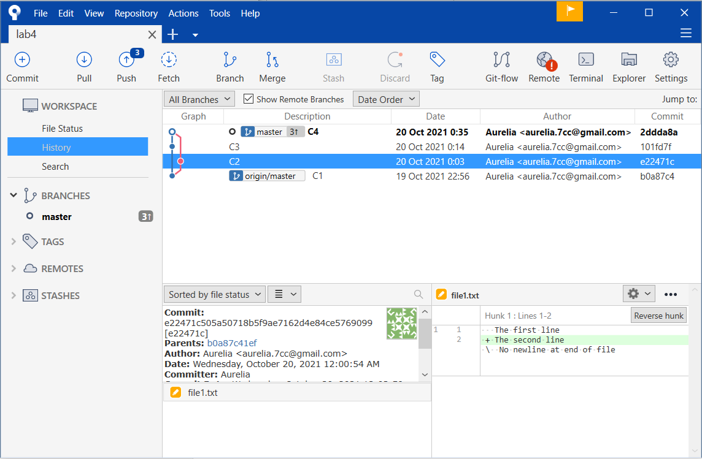

Make anotherBranch:

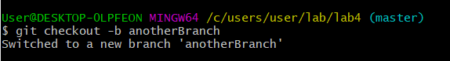

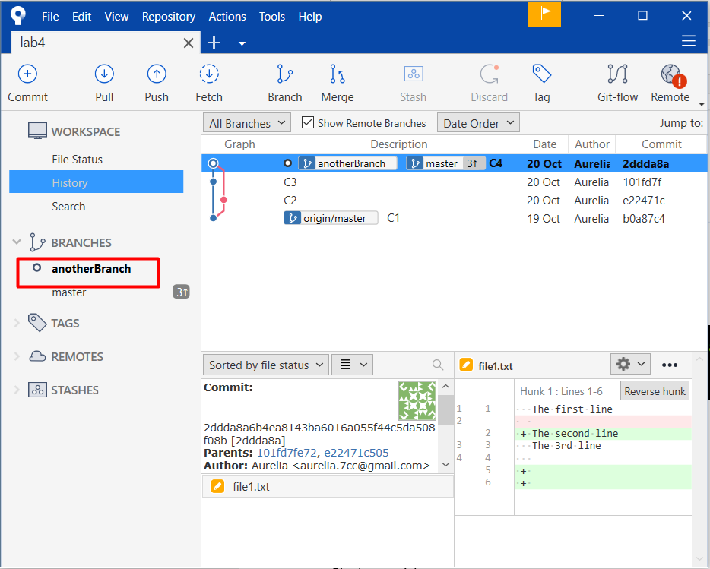

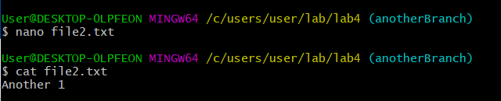

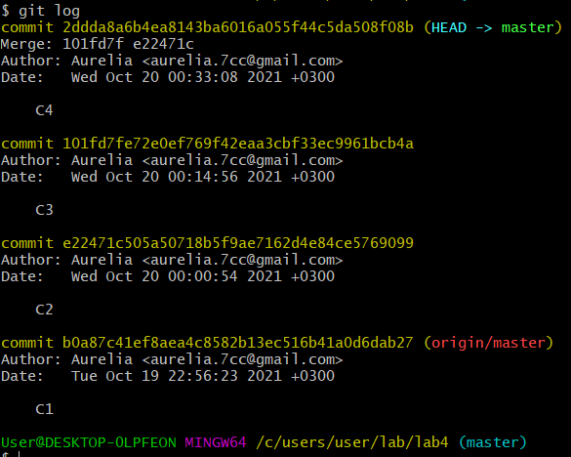

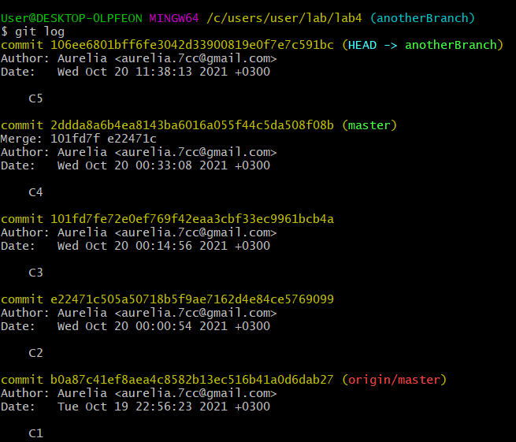

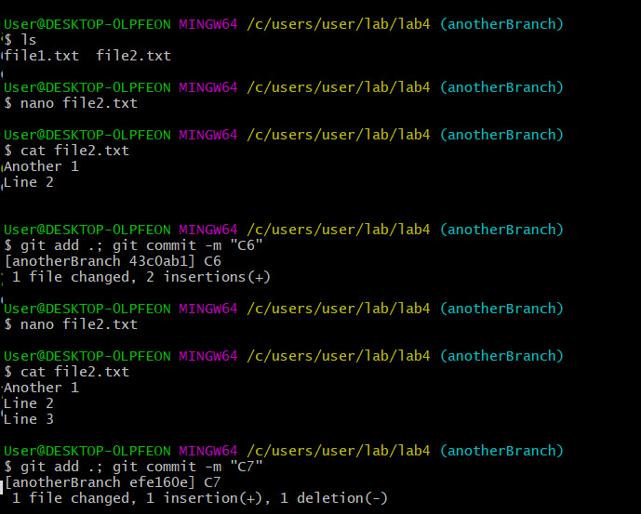

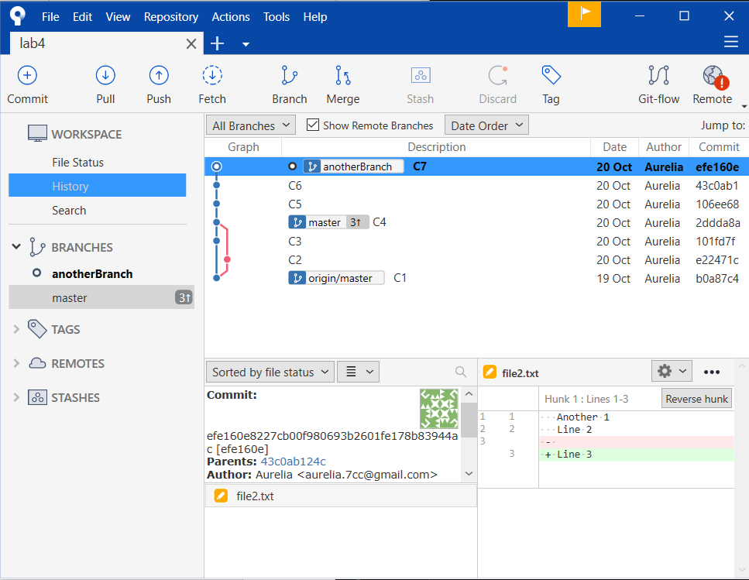

# git merge --squash

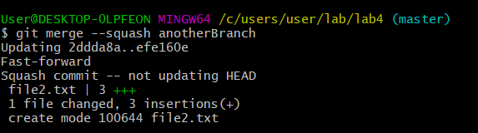

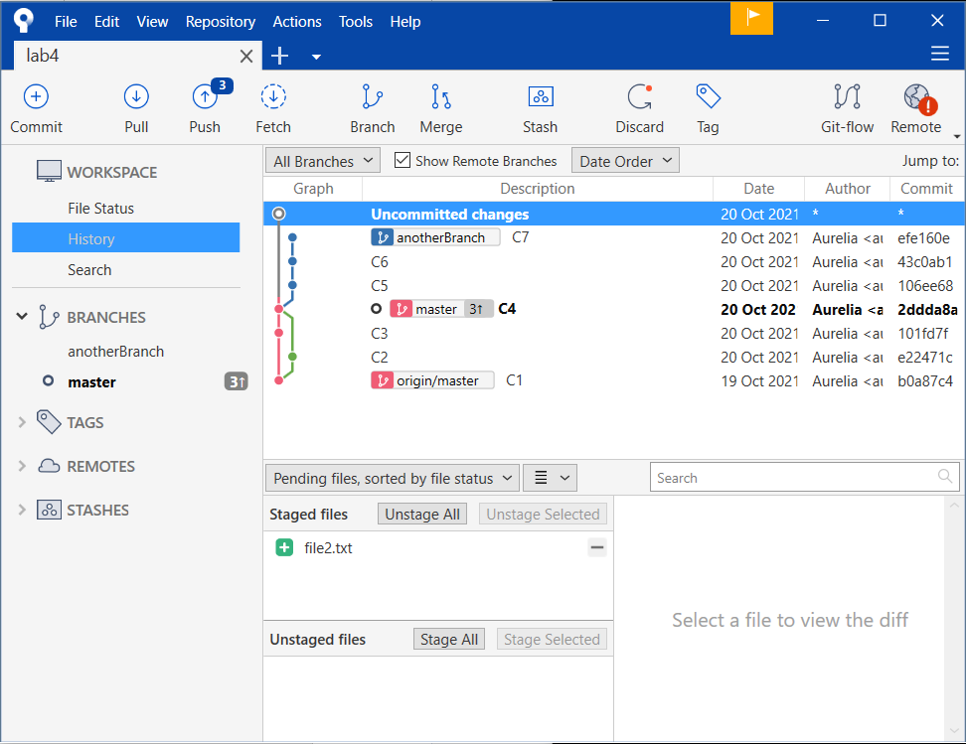

git commit

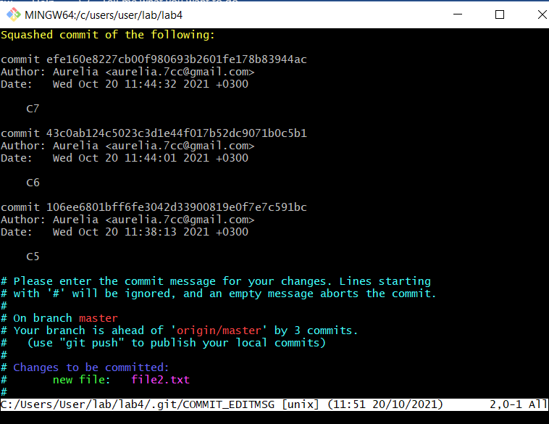

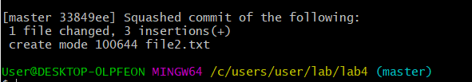

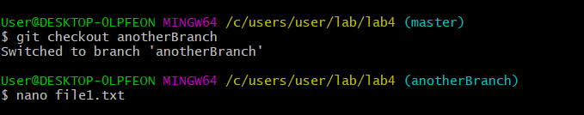

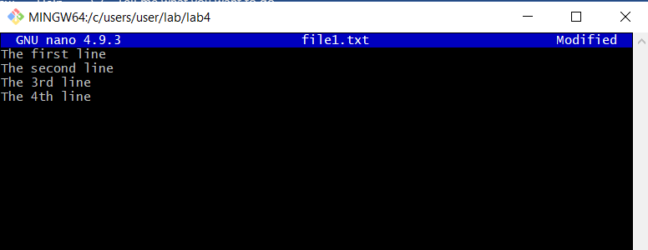

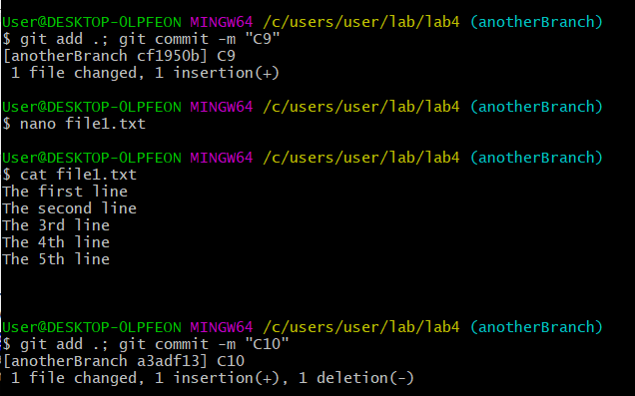

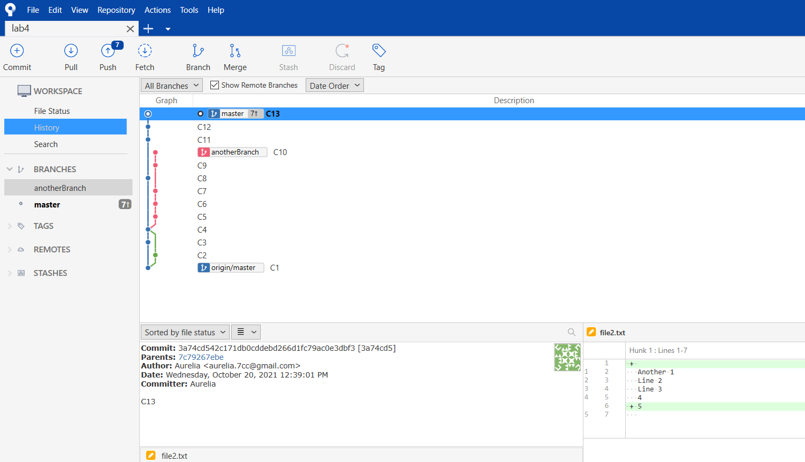

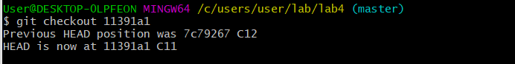

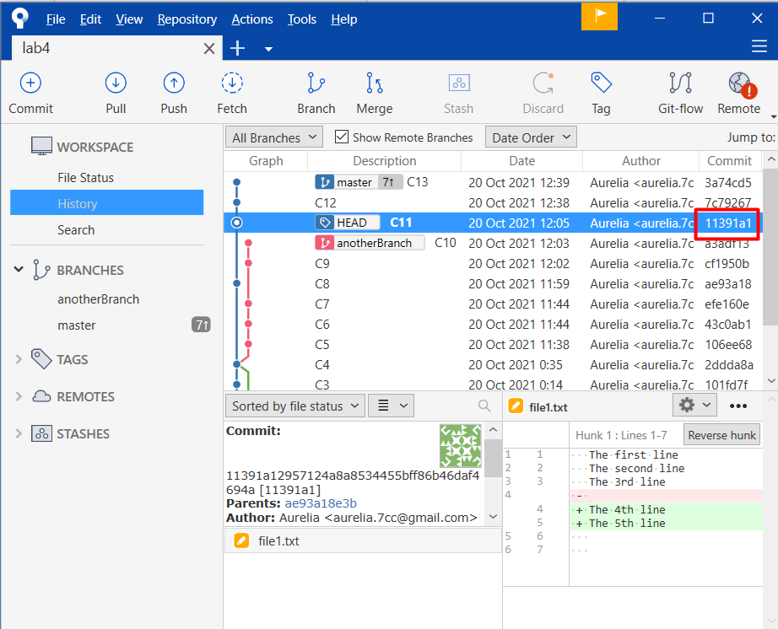

Or double click from Sourcetree

# git revert

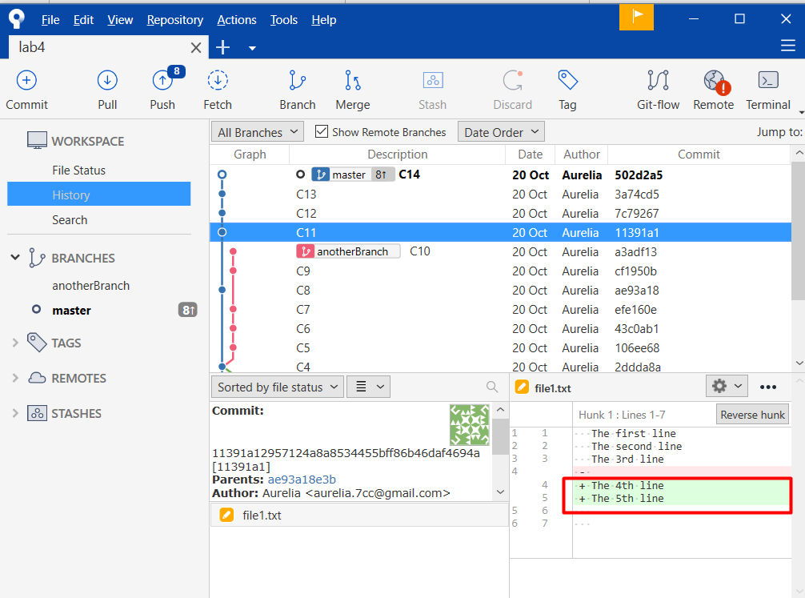

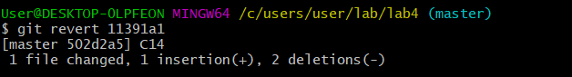

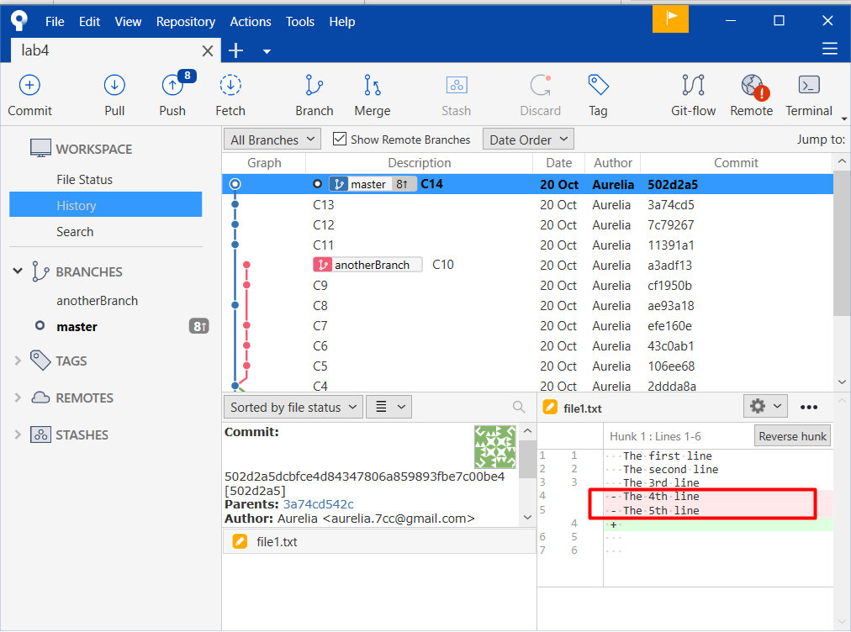

From the C14 2 lines have been deleted, C14 contains a revert of commit C11:

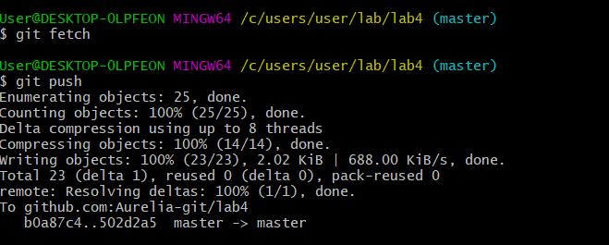

# git push origin/master

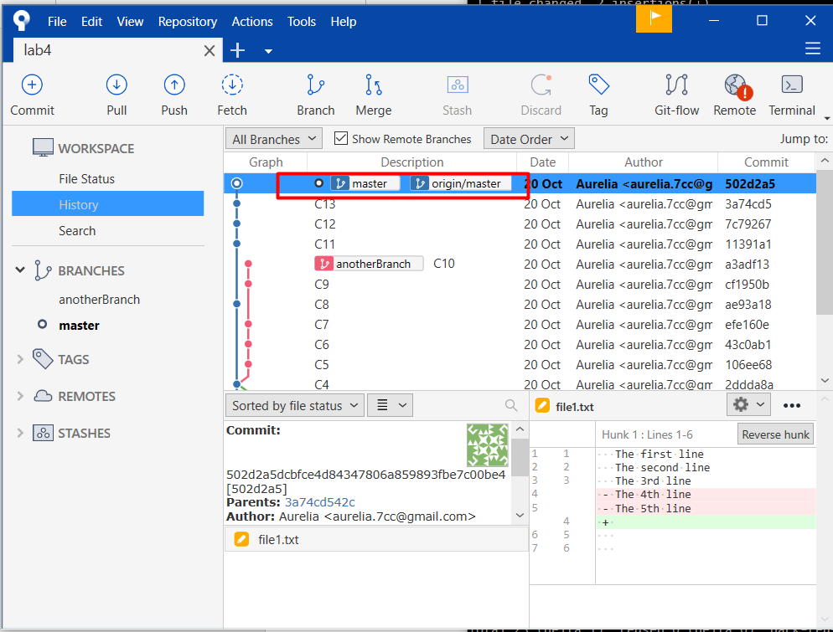

Origin/master:

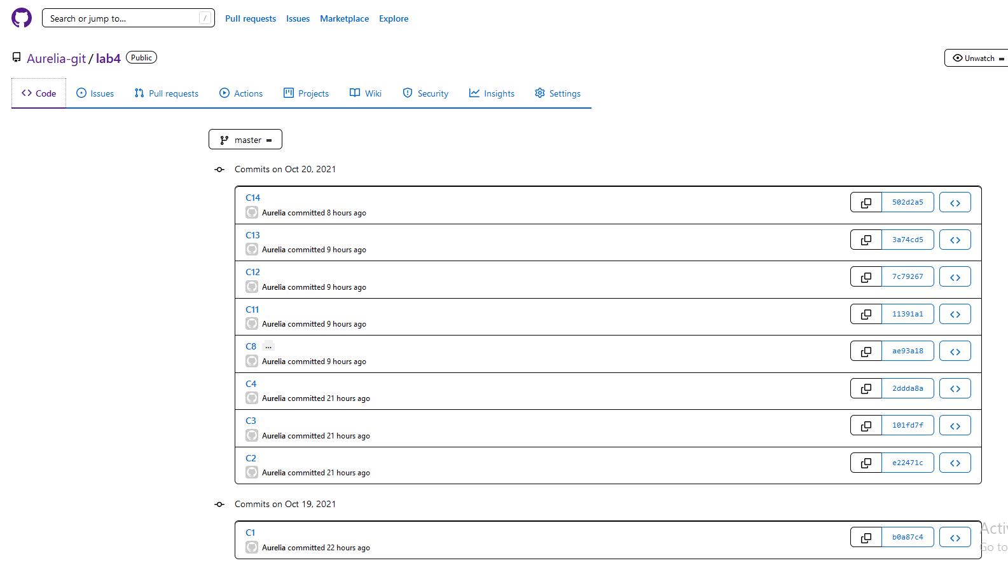

# git rebase

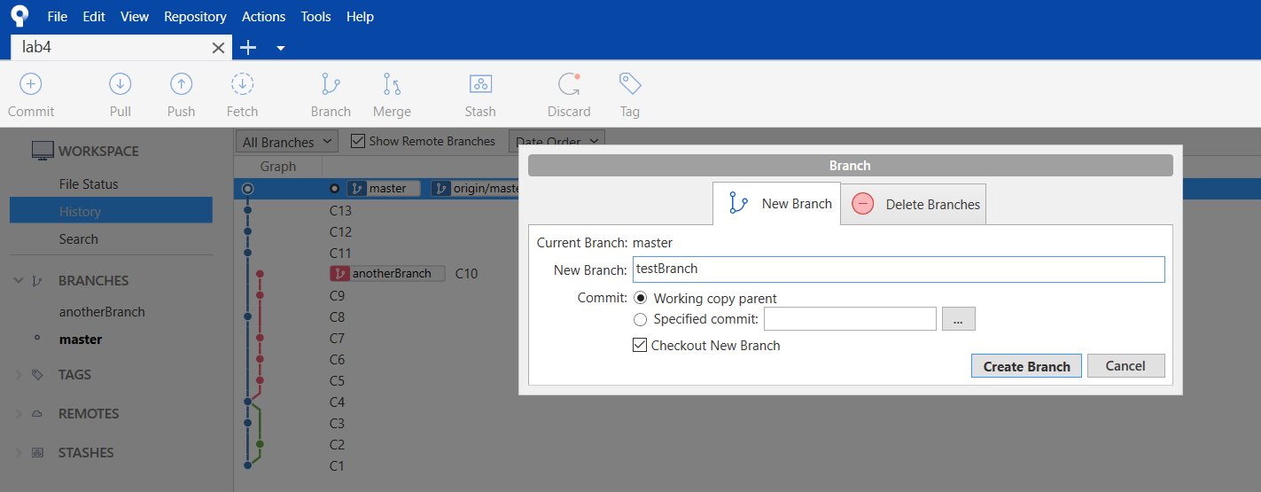

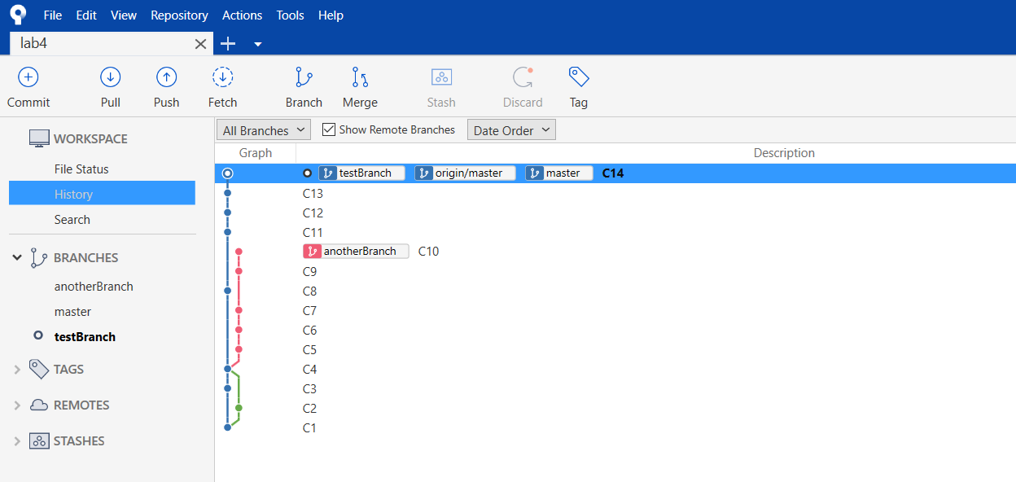

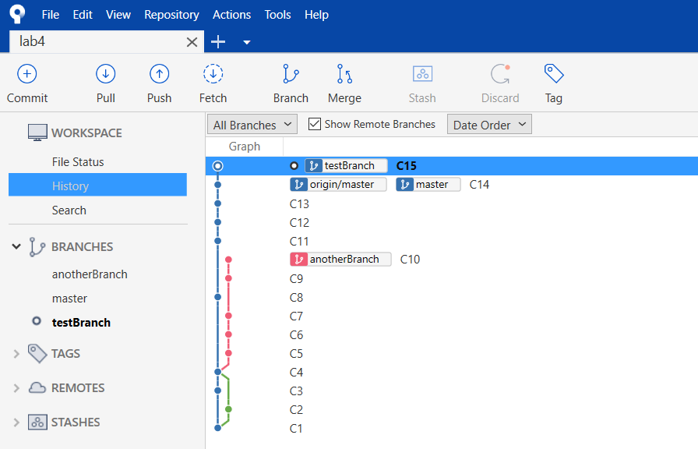

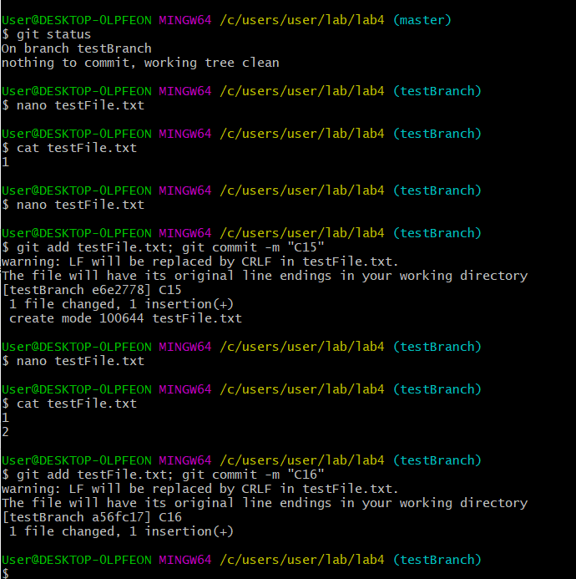

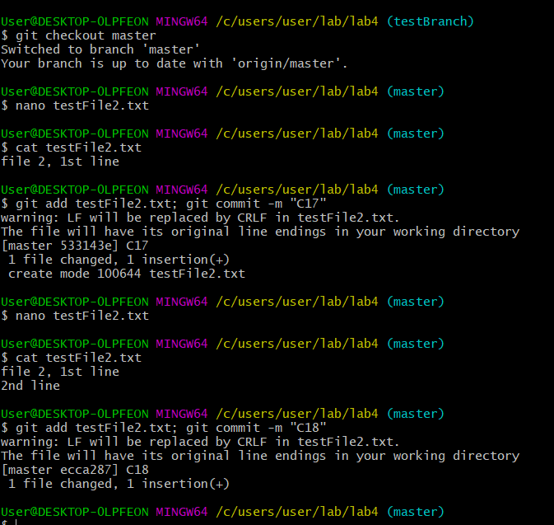

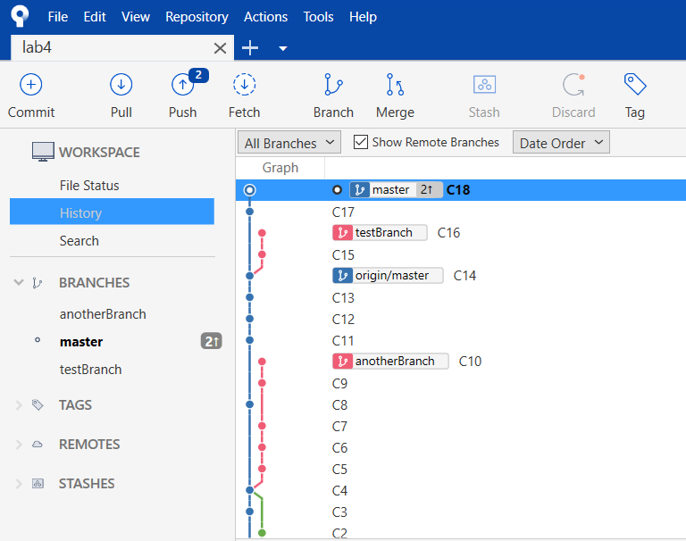

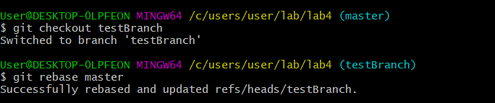

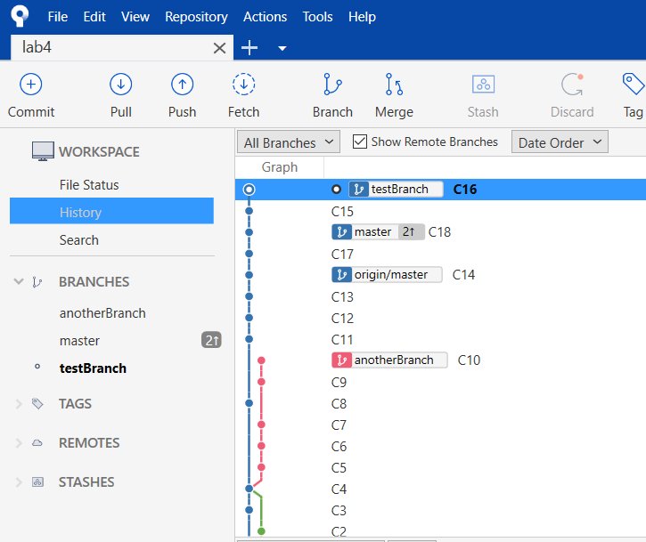

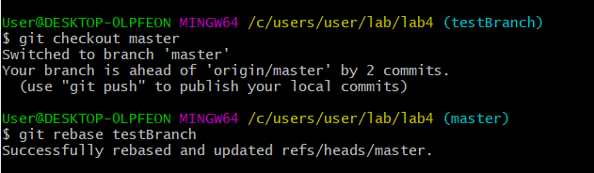

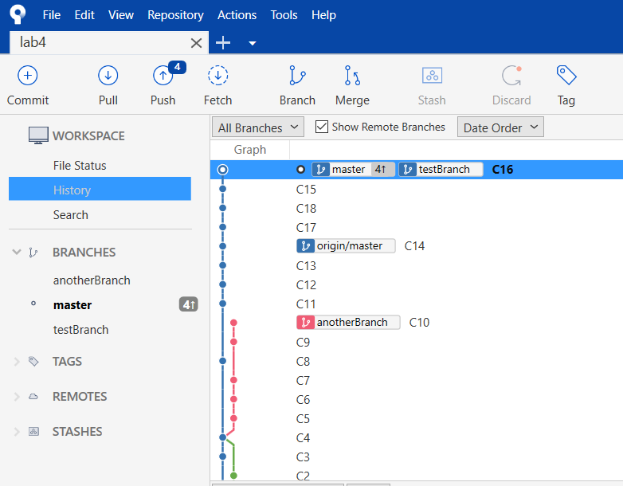

# git –amend

(Git –amend –no-edit)

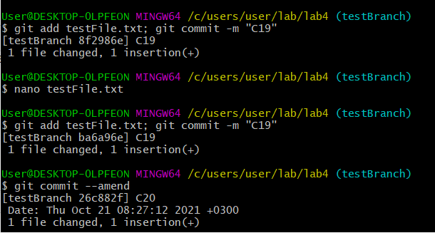

# git cherry-pick

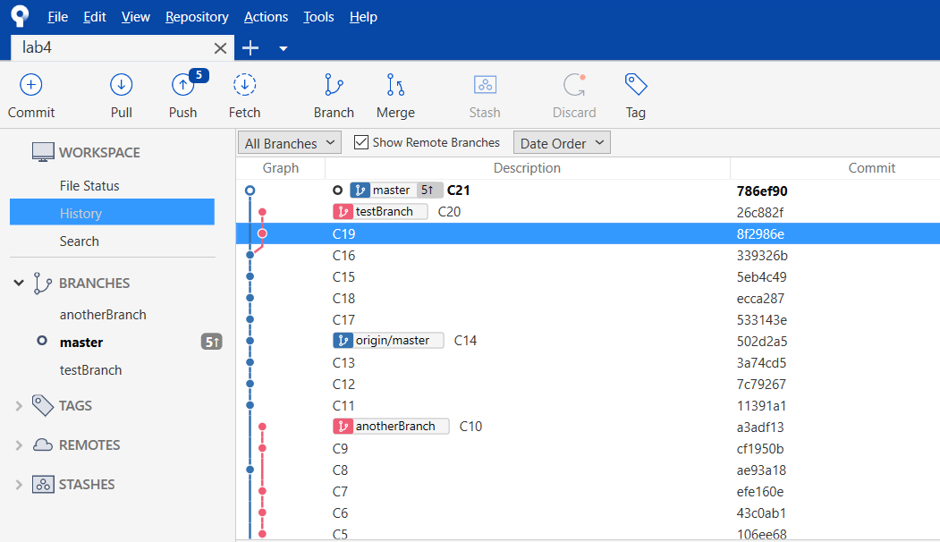

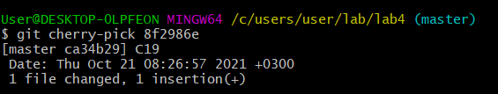

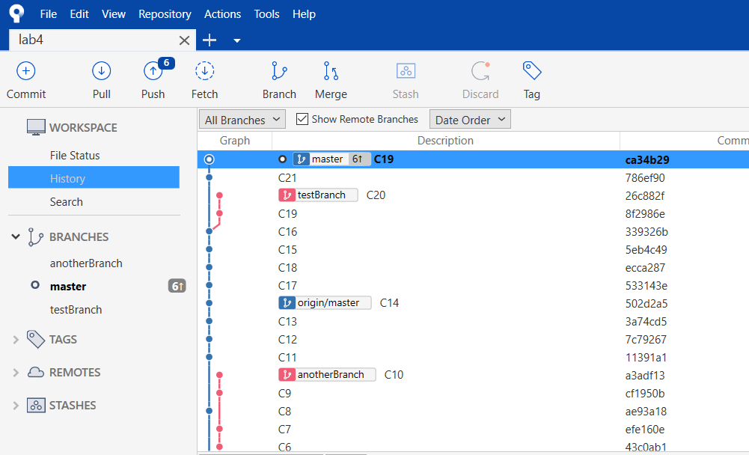

# git reset

1. **git reset –soft HEAD~1** (undo the last commit, keeping the changes in all files)

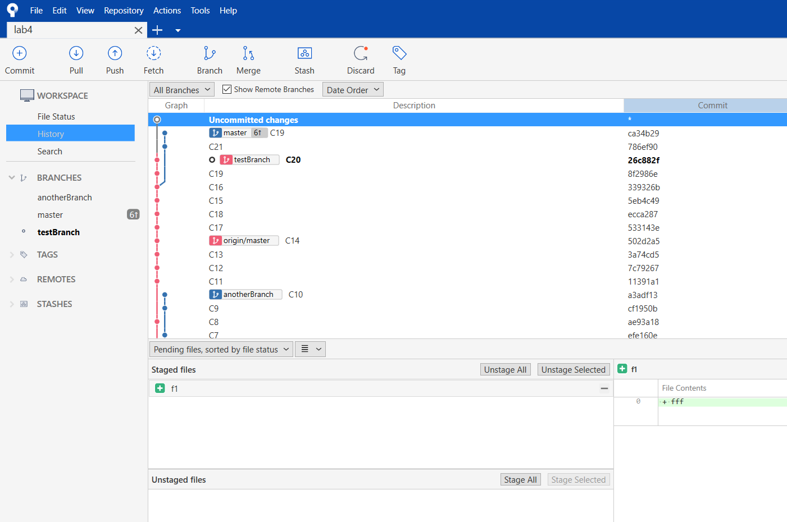

\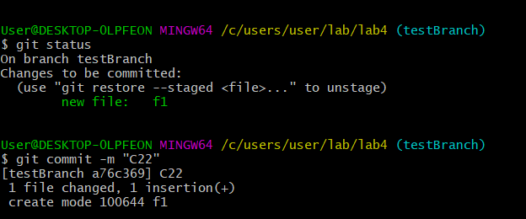

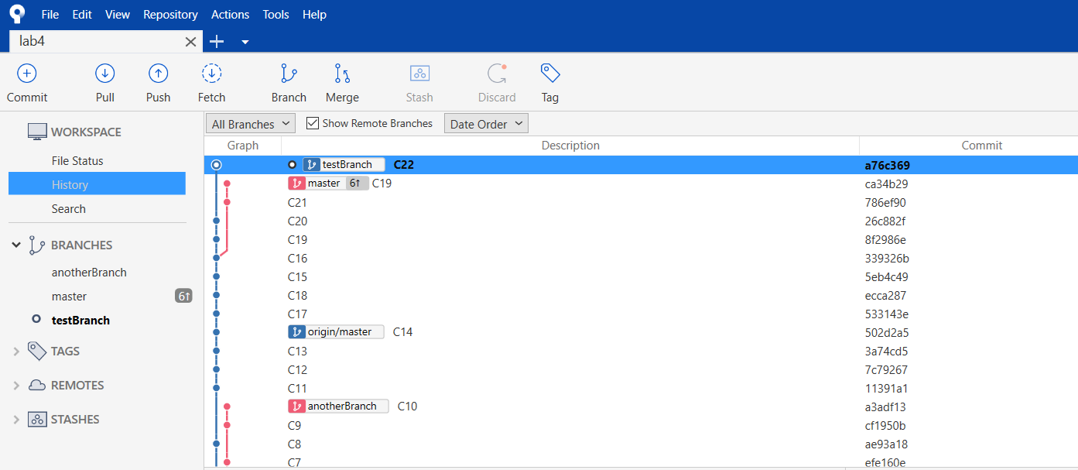

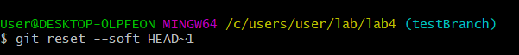

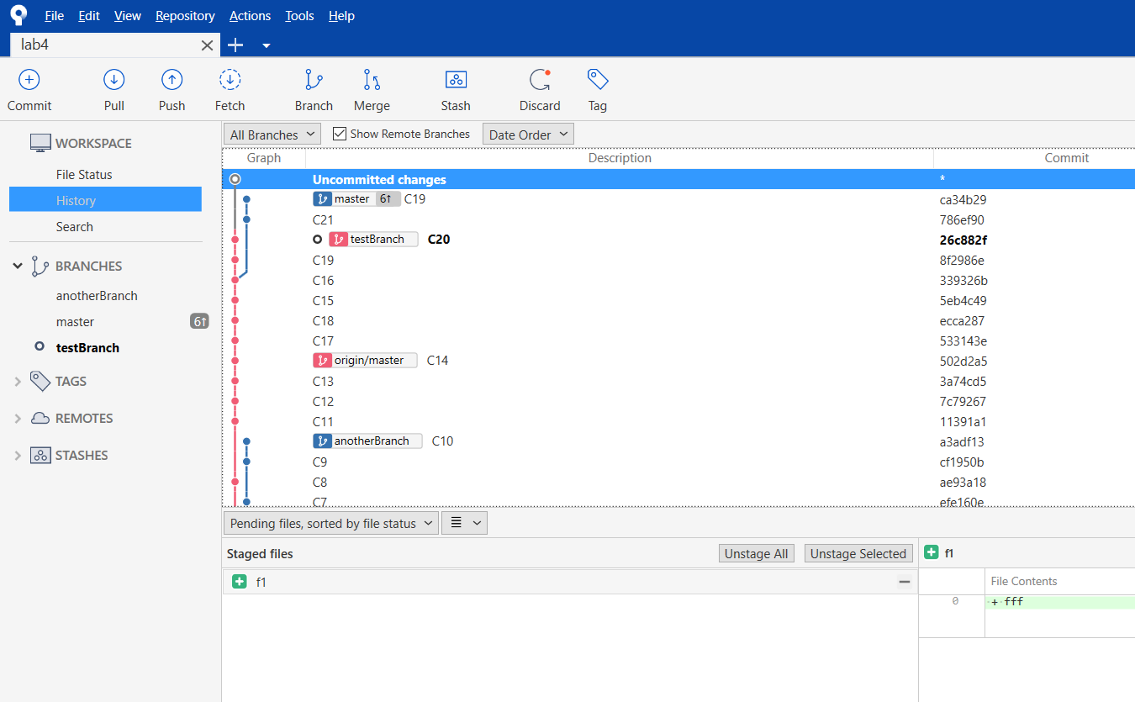

1. **git reset --hard HEAD~1**

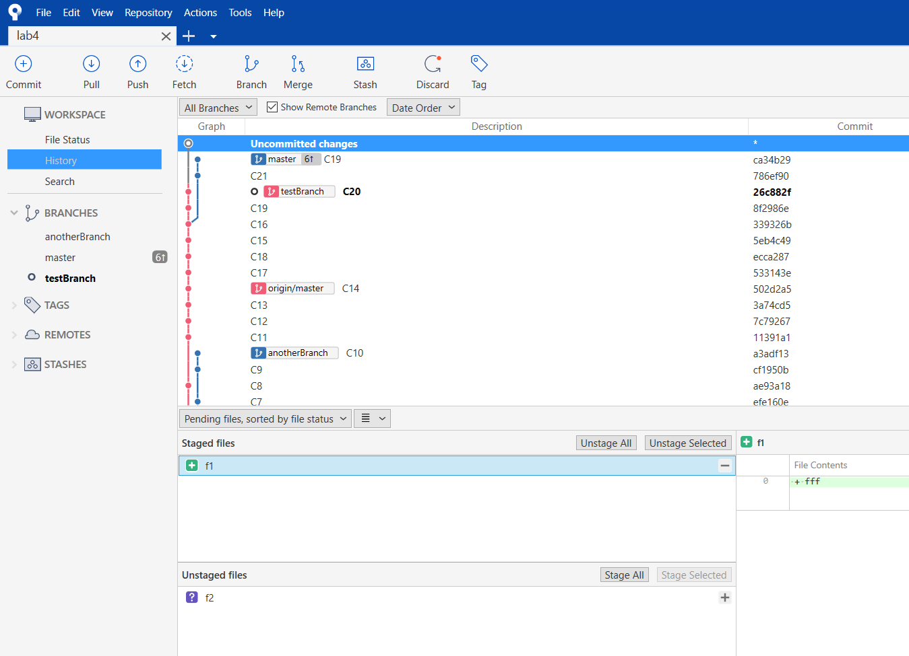

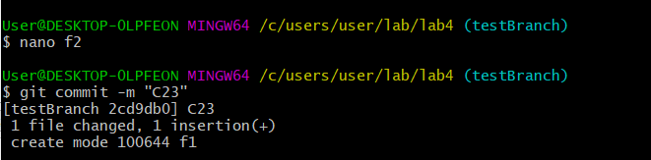

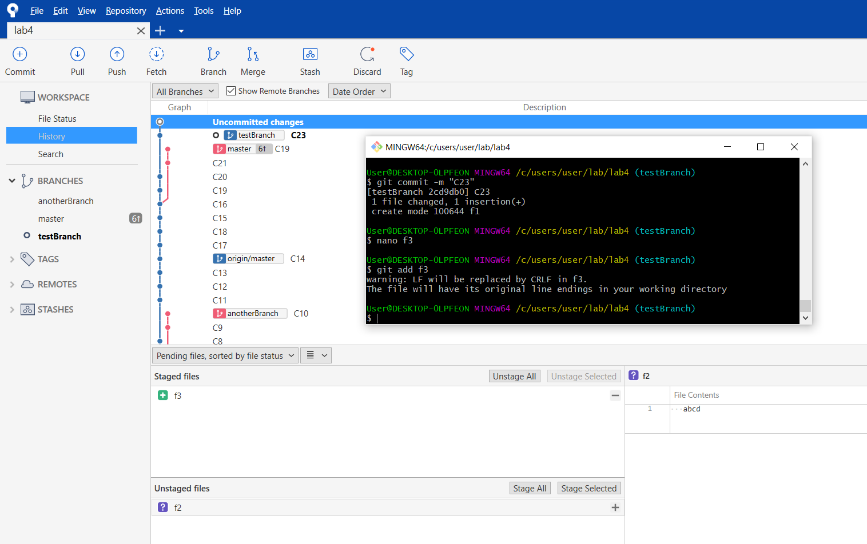

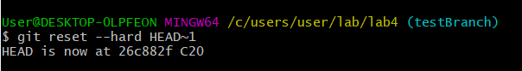

This command removed the commit C23, all together with all changes from the staged area.

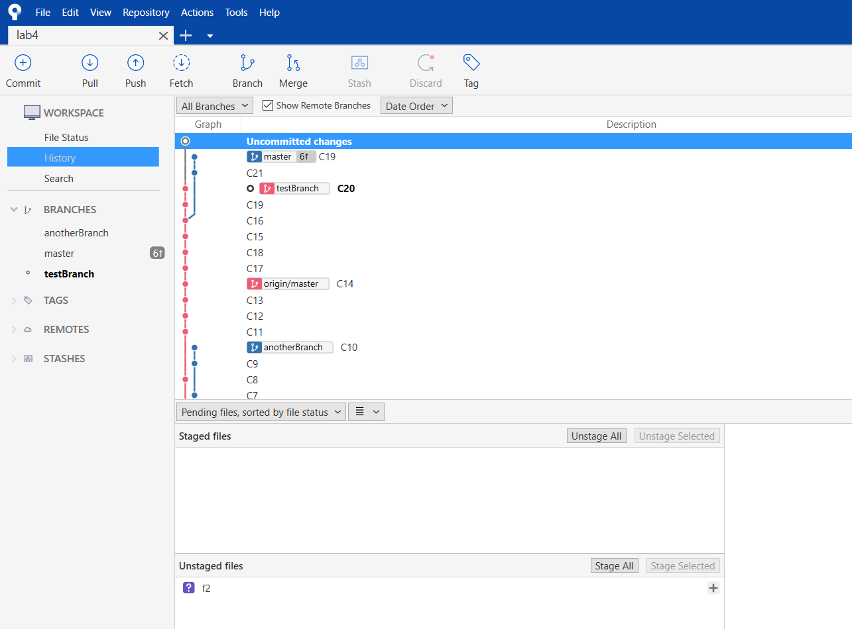

1. **git reset –mixed HEAD~1**

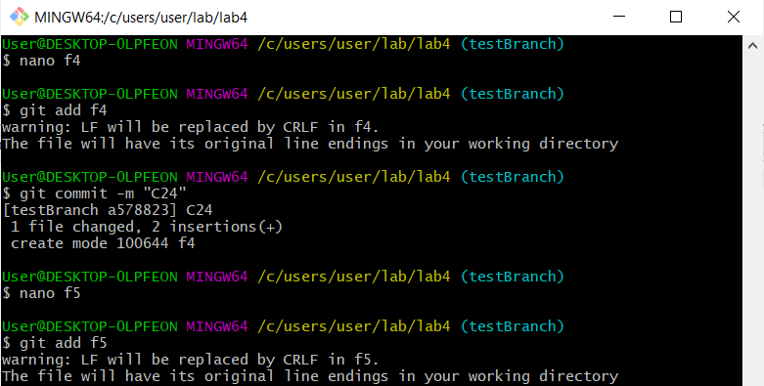

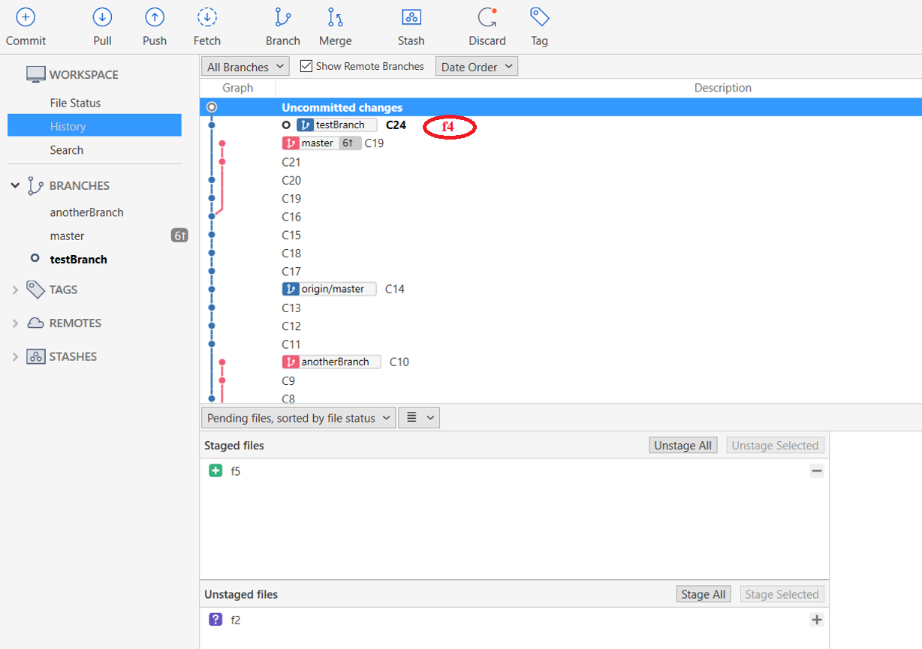



This command discards the commit C24 and all the changes from C24 and the staging area and they remain only in the Working directory (unstaged files).

